# Using Thermal Cameras to Count Number of Students Present in Lecture Theatres

**Introduction**

Thermal cameras detect heat through infrared radiation and convert it to visible light. As people radiate a lot of heat, and therefore infrared radiation, thermal cameras are effective at detecting people in a range of visible light settings. Thermal cameras do not require distinguishing features in order to identify people, making them ideal for anonymous person counting. This can be useful to track attendance and for determining the usage of the theatres to optimise when lectures are scheduled.

**Research**

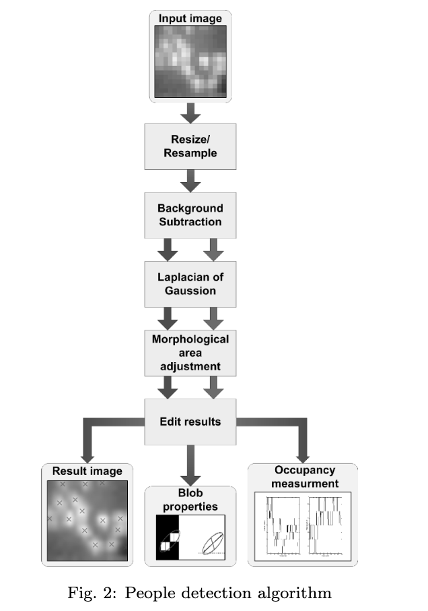There are many papers on the topic of tracking and counting people using thermal cameras. One paper, [**Room occupancy measurement using low-resolution infrared cameras**](https://www.researchgate.net/publication/224195975_Room_occupancy_measurement_using_low-resolution_infrared_cameras), uses a 16x16 pixel camera to determine the number of people in confined spaces such as an elevator. The method for processing these images are shown in Figure 1.

**Rescaling/Resample** - Using bicubic interpolation the image’s resolution is increased. This smooths out the low-resolution pixel to give a better indication of location of the blobs.

**Background Subtraction** - Firstly, some of background image and noise is removed by taking an average of multiple frames. The background is removed by using one of two methods. Either an image is obtained with no objects present, or the image is processed detecting the size and shape of the blobs and keeping ones that meet the required specifications. The first method was recommended, but they did address that this could be difficult to obtain.

**Laplacian of Gaussian** -The Laplacian of Gaussian is a method used to detect and count the number of blobs. The Gaussian function smooths the image like a mean filter. This removes a bit of detail and noise. The Laplacian highlights areas of rapid intensity change and is useful for defining the edges of the blobs. The factors of this method are particularly prone to the camera angle and position, making it difficult to use in different theatres.

**Morphological Area Adjustment** - As some individual people may be close by to each other, area adjustment is used to determine whether two blobs have merged. Through a series of dilation and erosions, the blobs are resized, then all blobs below a threshold are erased as noise.

Another tutorial I researched, [**OpenCV People Counter**](https://www.pyimagesearch.com/2018/08/13/opencv-people-counter/), follows a similar method for blob detection. Firstly, the image is converted to greyscale before being a threshold is applied to the image. Either Haar Cascades or HOG + linear SVMs method are used to detect the blobs and count them respectively. This tutorial does not account for any blob merging, but this may be achieved by increasing the threshold of the greyscale.

The lecture theatre is presumed to have relatively low-density crowding, therefore a relatively basic blob detection and counting as outlined above is assumed to be adequate. If the data shows that the lecture theatre is relatively high-density, other blob detection methods may need to be implemented. This may include deep-learning based methods such as Faster R-CNNs, YOLO, and Single Shot Detectors (SSDs) as indicated in this [tutorial](https://www.pyimagesearch.com/2018/08/13/opencv-people-counter/).

Figure 1 - People counting methodology using a low-resolution thermal camera.

Other papers, such as [**Automated people-counting by using low-resolution infrared and visual cameras**­­­­](https://pdfs.semanticscholar.org/1911/42ae4e22b078a7ea817a8c0887529617084d.pdf), also use Neural Networks to identify blobs in conjunction with an RGB camera to achieve a people counter with an accuracy of up to 3%. A fourth paper, [**Counting of People in the Extremely Dense Crowd using Genetic Algorithm and Blobs Counting**](https://pdfs.semanticscholar.org/b5d5/ba0652078dcf7540c538b92218d33145dbc1.pdf), uses a genetic algorithm to modify the thresholds to determine background and to determine the expected blob size when counting.

In general applications, blob detection is a relatively computationally intensive exercise. However, this is unlikely to be an issue when counting the number of people in a lecture theatre as the crowd will be mostly motionless. This means the counting does not have to happen in real-time and only a few images may need to be processed in order to establish the approximate number of students present.

**Issues**

**Working in different lecture theatres**

Different lecture theatres have different sizes and people capacity. This introduces a couple problems. Firstly, with varying sizes, the camera will be different distances and at different angles relative to the seated students. This will mean that the thermal camera blobs will be of varying sizes. This means that one static blob size threshold will likely not work in all theatres.Secondly, with some of the larger theatres, such as C2, it is possible that the camera angle will not be wide enough capture the entire seating arrangement. Therefore, it is possible that statistical relationships may need to be determined to calculate an accurate representation of the number of students. These ideas are currently outside the extent of this scope.

**Angle of thermal camera:**

The three possible orientations consider for the thermal camera placements are outlined in Figure 3. Firstly, a top view of the lecture would likely give the best vantage point for the camera in terms of image processing as students will be more clearly separated, reducing the number of thermal blobs created by multiple individuals.

Front Bottom

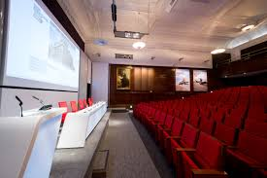

Top View

Front Top

Figure 3 - Proposed thermal camera views.

The next orientation would be the front top angle. This angle may mean that the blobs of students sitting in front of one another will blur into each other. This may create an extra-large blob that may accidently be counted as one person instead of two. A small number of these blobs may be able to be processed.

The final orientation considered in the front bottom angle. This would be the easiest to install but will likely create a large problem with blob merging and will not be pursued.

**Distortion of thermal camera:**

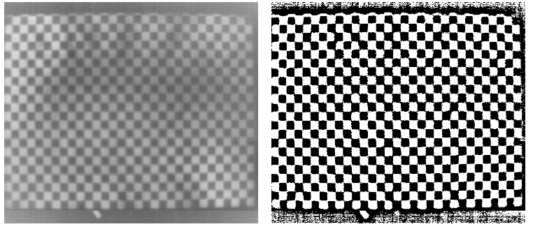For RGB cameras, the distortion created by the lenses are determined and accounted for by using visual points, such as on a checkerboard. The same distortion can occur with thermal cameras, however there is not a reliable method yet for calculation and accounting for this distortion. Because thermal cameras only respond to heat, typically images such as a checkerboard do not reliably show. One method, proposed in this [paper](https://www.researchgate.net/publication/224264150_Lens_distortion_correction_for_thermal_cameras_to_improve_aerial_imaging_with_small-scale_UAVs), was to heat up the chessboard using either sunlight or IR lamps. This causes the black spots on the board to heat up more than the white spots and allows a thermal camera to detect the checkerboard. Some image processing is required before a checkerboard can be extracted and used with distortion calculating code typically used with RGB cameras. This may be worth looking into, depending on how bad the image of lecture theatres is distorted, however further testing would be required.

Figure 2 - Thermal image of checkerboard processed and ready to be used to calculated distortion.

**Method**

Thermographic images represent the

electromagnetic radiation of an object in the far

infrared range, which is 6 − 15µm. The principle of

Thermography is based on the physical phenomenon

that any body of a temperature above absolute zero

(-273.15 °C) emits electromagnetic radiation.

Thermographic images represent the

electromagnetic radiation of an object in the far

infrared range, which is 6 − 15µm. The principle of

Thermography is based on the physical phenomenon

that any body of a temperature above absolute zero

(-273.15 °C) emits electromagnetic radiation.

Going forward, the plan is to collect some test data and begin processing. Generally, I will try to follow the methods outlined in the [**Room occupancy measurement using low-resolution infrared cameras**](https://www.researchgate.net/publication/224195975_Room_occupancy_measurement_using_low-resolution_infrared_cameras) paper. Ideally, this will also include a background image of the lecture theatre with no people present in order to use some background subtraction. This will hopefully remove most noise coming from sources like lights or other heat sources. I will likely begin with thresholding and basic blob detection methods such as Haar cascade or HOG + linear SVM on images taken from a top view. Once this is working, I will look to implement more complicated blob detection methods such as Laplacian on Gaussian or a pretrained Neural Network on front-top views. If these processes work, I will begin to look at working in different lecture theatres, statistical models and the distortion of the thermal cameras.

Further research will be completed in order to determine what the best method for blob detection is and the quality of the thermal camera images.

Thermographic images represent the

electromagnetic radiation of an object in the far

infrared range, which is 6 − 15µm. The principle of

Thermography is based on the physical phenomenon

that any body of a temperature above absolute zero

(-273.15 °C) emits electromagnetic radiation. T

Thermographic images represent the

electromagnetic radiation of an object in the far

infrared range, which is 6 − 15µm. The principle of

Thermography is based on the physical phenomenon

that any body of a temperature above absolute zero

(-273.15 °C) emits electromagnetic radiation. The

Thermographic images represent the

electromagnetic radiation of an object in the far

infrared range, which is 6 − 15µm. The principle of

Thermography is based on the physical phenomenon

that any body of a temperature above absolute zero

(-273.15 °C) emits electromagnetic radiation. Th

Thermographic images represent the

electromagnetic radiation of an object in the far

infrared range, which is 6 − 15µm. The principle of

Thermography is based on the physical phenomenon

that any body of a temperature above absolute zero

(-273.15 °C) emits electromagnetic radiation. The

Yang D., H. González-Baños, and L. Guibas(2003):

Counting people in crowds with a real-time

network

Yang D., H. González-Baños, and L. Guibas(2003):

Counting people in crowds with a real-time

network